**Day 17 Build FeedBack Collector App**

🔧 Installation Guide: Setting Up Environment for Anaconda

🐍 Step 1: Install Anaconda (Includes Jupyter Notebook)

1. Go to the official Anaconda download page:  
   🔗 <https://www.anaconda.com/products/distribution>
2. Download the installer based on your operating system:
   * Windows: Anaconda3-x.x.x-Windows-x86_64.exe
   * macOS: Anaconda3-x.x.x-MacOSX-x86_64.pkg
   * Linux: .sh file
3. Run the installer and follow the installation steps:
   * Click Next > Agree to license > Choose "Just Me" > Default install location is fine
   * Check "Add Anaconda to PATH" if prompted (optional but helpful)
   * Finish installation

🧪 Step 2: Open Jupyter Notebook

After installing Anaconda:

1. Open the Anaconda Navigator from the Start Menu
2. Click on Launch under Jupyter Notebook

This will open a Jupyter Notebook interface in your browser (usually at http://localhost:8888), and from there, you can create and edit .ipynb files.

⚙️ Step 3: Create a New Jupyter Notebook

1. In the Jupyter browser tab, click New → Python 3 (ipykernel).
2. A new notebook will open where you can start writing Python code.

📦 Step 4: Install Required Python Libraries

Open Anaconda Prompt (or Terminal if you're on macOS/Linux) and run the following commands one by one:

Bash:

pip install streamlit

pip install pandas

pip install textblob

python -m textblob.download_corpora

📌 Explanation:

* streamlit: For creating the web app interface
* pandas: For handling feedback data
* textblob: For sentiment analysis
* download_corpora: Downloads necessary resources for TextBlob to analyze text

Cell 1: Import Libraries

python

import streamlit as st

import pandas as pd

from textblob import TextBlob

import os

💬 Cell 2: Sentiment Function

python

def get_sentiment(feedback):

analysis = TextBlob(feedback)

polarity = analysis.sentiment.polarity

if polarity > 0:

return "😊 Positive"

elif polarity < 0:

return "😠 Negative"

else:

return "😐 Neutral"

💾 Cell 3: Save Feedback to CSV

python

def save_feedback(feedback, sentiment, filename="feedback_data.csv"):

df = pd.DataFrame({'Feedback': [feedback], 'Sentiment': [sentiment]})

file_exists = os.path.exists(filename)

df.to_csv(filename, mode='a', header=not file_exists, index=False)

🖥️ Cell 4: Streamlit Web App Code

python

st.set_page_config(page_title="Feedback Collector", page_icon="📝")

st.title("📝 Feedback Collector with Sentiment Analysis")

st.write("We'd love to hear your thoughts. Please leave your feedback below:")

feedback = st.text_area("Your Feedback", height=150)

if st.button("Submit"):

if feedback.strip() == "":

st.warning("⚠️ Please enter some feedback before submitting.")

else:

sentiment = get_sentiment(feedback)

save_feedback(feedback, sentiment)

st.success("✅ Feedback submitted successfully!")

st.info(f"**Detected Sentiment:** {sentiment}")

💾 Step 6: Export Notebook as .py File

Once you’ve tested your code in the notebook:

1. Go to File → Download as → Python (.py)
2. Save it as feedback_app.py

🚀 Step 7: Run the App Using Streamlit

1. Open Anaconda Prompt
2. Navigate to your file's folder:

bash

cd path\to\your\notebook\folder

1. Run:

bash

streamlit run feedback_app.py

This will launch the app in your browser 🎉

**Final Output:**

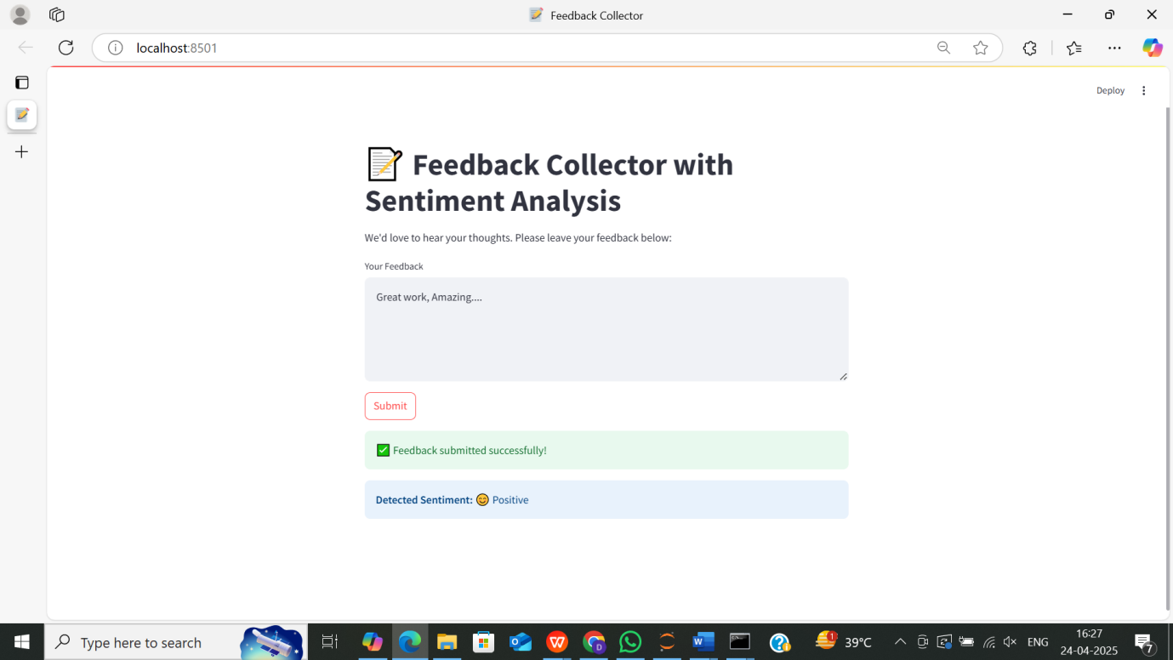

**Data Storage: Saving Feedback in CSV**

